The four P’s of storytelling

# People:

Graham Sterling (Player)

Mary Sterling (Wife Deceased)

Rebecca Moore (Daughter)

George Moore (Son in-law)

Samuel Moore (Grandson)

Jane Moore (Granddaughter)

Dr. James Cranston (Doctor)

# Place:

Grahams house

Hospital

# Picture:

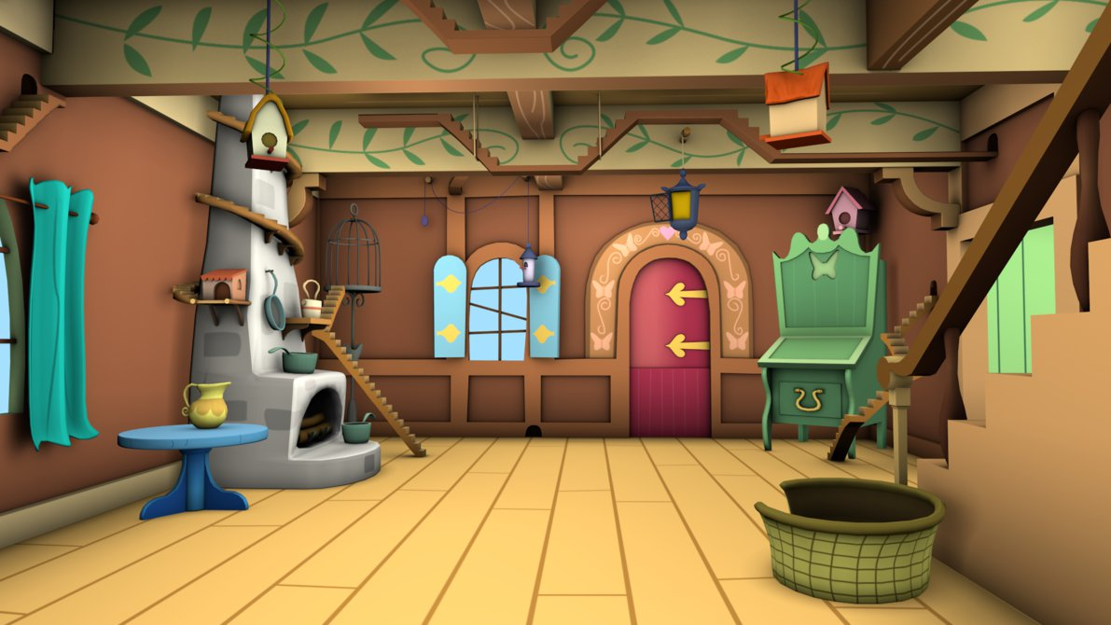



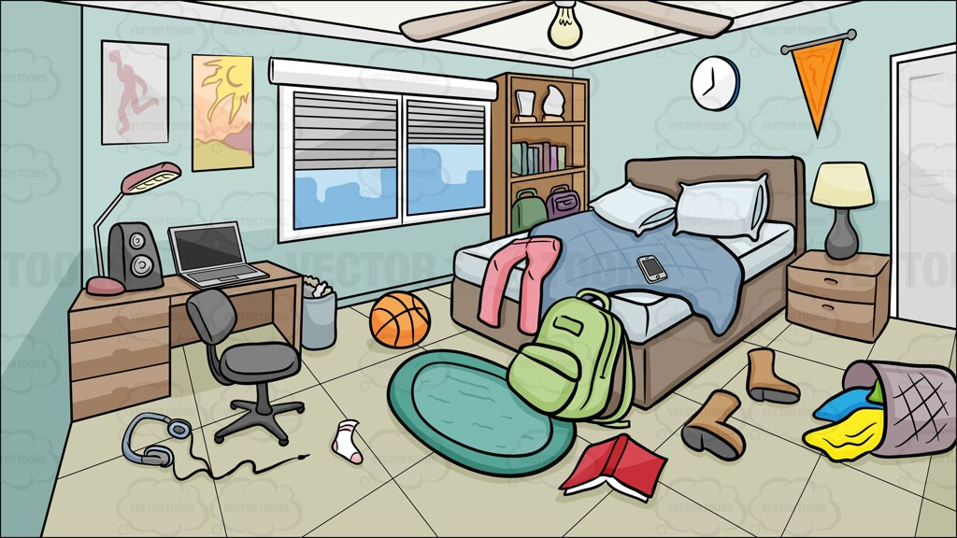



# Plot:

You play as Graham Sterling, an old man with severe dementia. After the loss of his wife Mary he goes insane and is hospitalised. He then lives the next 7 days in a dream while his family decide weather to pull the plug and let him die or force him to life in an insanity fuelled daydream.

On the first day he lives it through as if nothing had changed but he repeats a task once. All the colours are normal, and his wife is still alive.

On the second day his wife is alive but is moving much less and looks frailer than she did before. He repeats another task a few times at different stages through the day. He puts things down and they move into other locations. He looks at a picture of his daughter and grandchildren and doesn’t recognise then.

On the third day his wife is no longer there, and he spends the whole day searching for her. He puts things down and they exit the level. Giving the illusion that he has lost it.

On the fourth day he acts as if his wife has been dead for a while and goes about his every day as if nothing had happened the day before. When you put items down they appear in other places, as if he had forgotten where he put them. He repeats his tasks a few times and says the same thing after a while.

The fifth day and the sixth day he feels like he is a teenager and he has just moved into his house

Idea

* 1st person.
* Slowly losing memory.
* Play through 7 days.
* Each day you have to do one task one more time than the last day.
* You slowly lose your memory.
* Colours are slowly getting duller and turn grey.
* You wake up in a hospital bed surrounded by your family.

Setting:

* Old person’s house
* Hospital
* House contains Kitchen, Living room, Bathroom, Bedroom, Garden and Dining room.

Character Profile

Graham Sterling

76-year-old man living alone after his wife’s death.

Severe dementia

Graham is an old man living alone after his wife has died and is living with severe dementia. He is living in an everyday week of his life with small references to show that he is loving inside of a memory. He can hear some conversations from the outside world and he can hear a heart rate monitor whenever there’s a dark screen during the transition of days.